**NAIVE BAYES**

**Business Problem** = ﻿Build a naive Bayes model on the data set for classifying the ham and spam.

* **Name of the File: -** sms_raw_NB.csv
* **Size of the File: -** 479 KB
* **Necessary Data : -** 5559 Observations, 2 Features.

**Exploratory data Analysis** =

* **Outliers: -**  Outliers are not presents.
* **Missing Value: -** Data don’t have Missing Values
* **Output:** - Categorical
* **Sampling:**- Stratified Sampling. ﻿ (Spam = 87%, Ham = 13%)

**Model Building =** After model building we can conclude that﻿ Multinomial Naive Bayes Model gives us more accuracy as compare to Gaussian Naive Bayes. So We are selecting Multinomial Naive Bayes for the Future Predication.

* **Accuracy Score Train:-** 99 %
* **Accuracy Score Test:-** 98 %
* 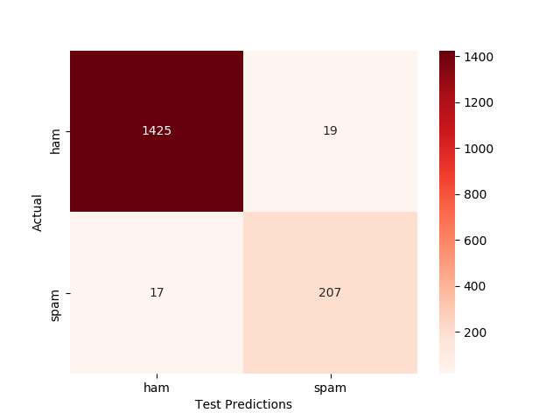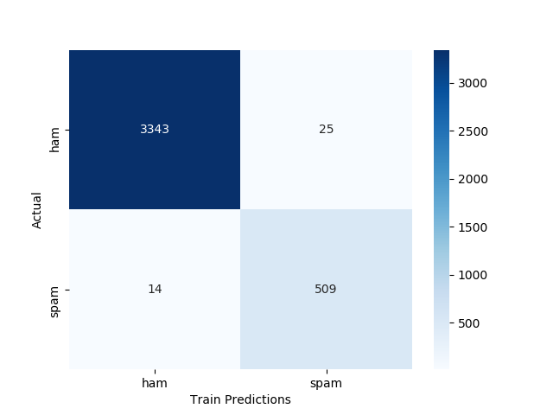**Confusion Matrix : -**

**Python code file**: - [Sms Data Analysis.py](https://github.com/nilaydeshmukh0/Naive-Bayes-Classifier/blob/master/Sms%20Data%20Analysis/Sms%20Data%20Analysis.py)